**SOP for UBuntu 14.04 LTS**

**Step 1:** Open Terminal Ctrl+ALT+t

Type sudo nano /etc/hosts and make the changes as per screenshot

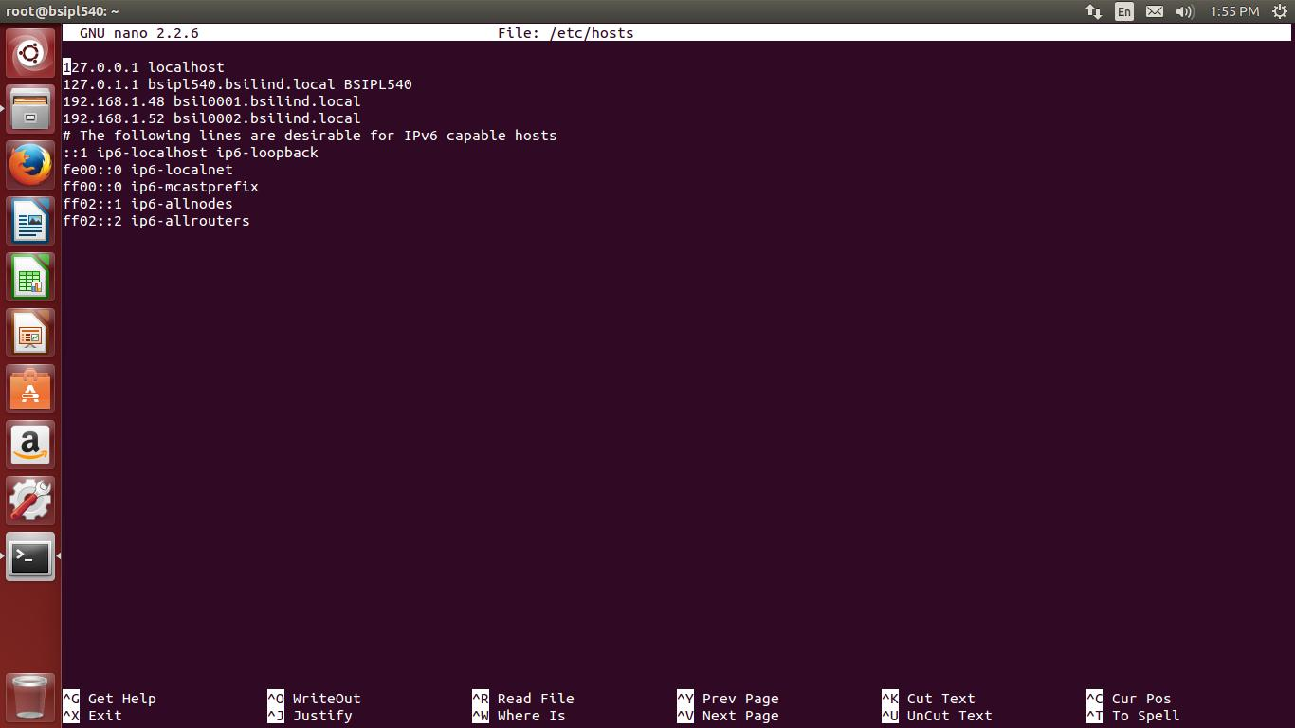

**Note:** Type the AD and ADC servers IP Address and server name

**Step 2:** Type sudo nano /etc/nsswitch.conf

* Search for the line that says

hosts: files mdns4_minimal [NOTFOUND=return] dns mdns4

* Put # infront of that line and add a new line

hosts: files dns mdns4

* So that the file will look like

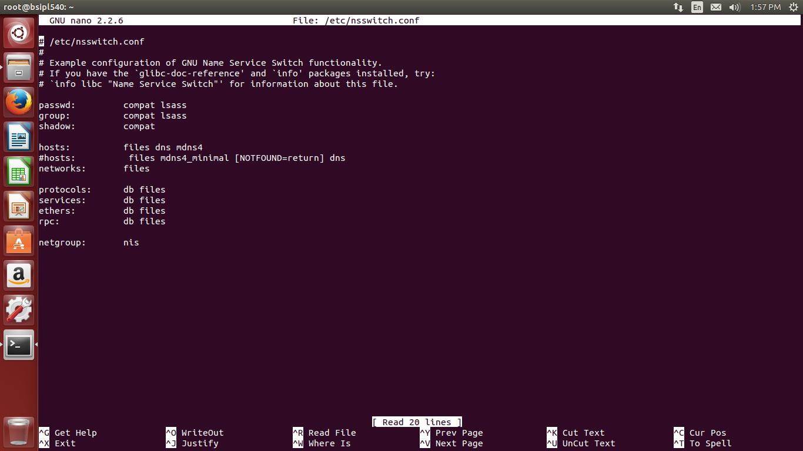

**Step 3:** Type sudo nano /etc/resolv.conf

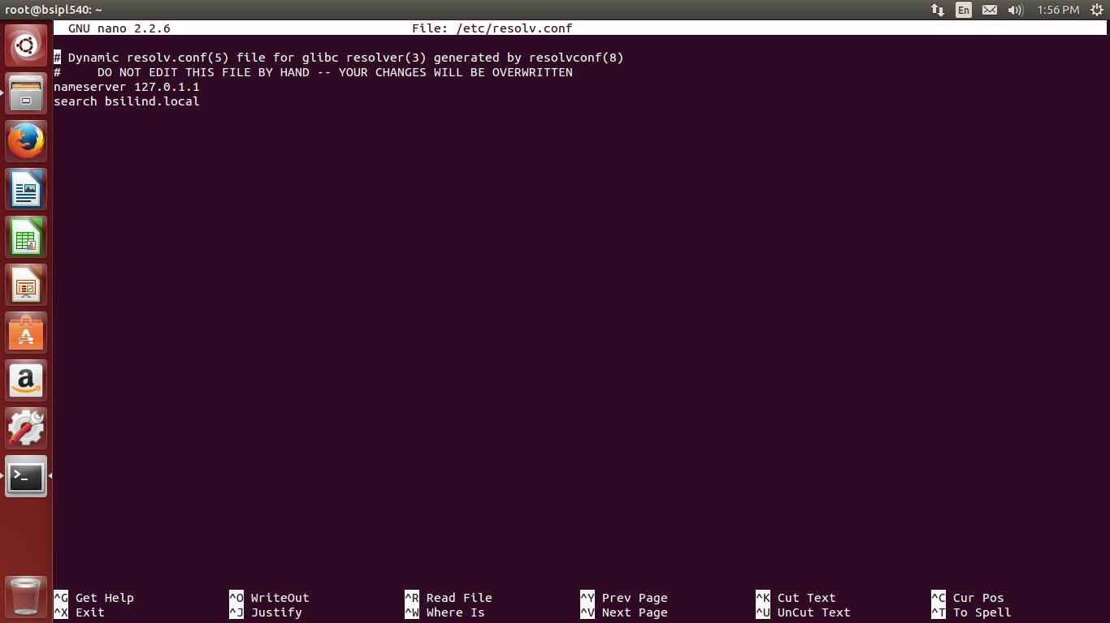

* Type the AD and ADC servers IP Address in the place of loopback address next to nameserver as shown in the Screenshot
* Leave search domain name as shown in the Screenshot

**Step 4:** use a software package called “Power Broker Identity Services, Open Edition” to join to windows domain

1. Type sudo –s and login as root
2. Download from the below URL

<http://download1.beyondtrust.com/Technical-Support/Downloads/PowerBroker-Identity-Services-Open-Edition/?Pass=True>

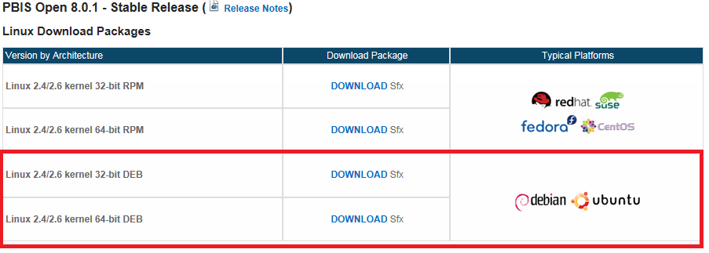

or

**From the Terminal type:**

wget <http://download.beyondtrust.com/PBISO/8.0.0.2016/linux.deb.x64/pbis-open-8.0.0.2016.linux.x86_64.deb.sh>

1. **To make the Power Broker Identity Services installation script executable**

* In the terminal navigate to the directory where pbis-open-8.0.1.2029.linux.x86_64.deb.sh is located and execute the following command:

sudo chmod a+x pbis-open-8.0.1.2029.linux.x86_64.deb.sh

1. **Run the Power Broker Identity Services by running the below command**

sudo ./pbis-open-8.0.1.2029.linux.x86_64.deb.sh

**Step 5:** Type sudo nano /etc/resolv.conf and check the configuration, if it looks as

it is in Step 3: then goto next Step 7: or else follow Step 3: and then goto

Step 6:.

**Step 6:** **To join your Ubuntu Desktop to the Windows Domain**

**From the terminal:**

cd /opt/pbis/bin/   
sudo domainjoin-cli join --disable ssh $domainname $domainaccount

*where domainname = the name of your domain and domainaccount = user@domainname.###

EXAMPLE: sudo domainjoin-cli --disable ssh botree.com [admin@botree.com](mailto:admin@botree.com)

When prompted for a password supply the appropriate credentials and you should receive a "SUCCESS" prompt when finished.

**Step 7:** Restart your machine

**Step 8**: **Set-up default configuration for domain users**

1. Login as root by typing sudo –s
2. From the terminal type the below command

/opt/pbis/bin/config UserDomainPrefix botree  
/opt/pbis/bin/config AssumeDefaultDomain true  
/opt/pbis/bin/config LoginShellTemplate /bin/bash  
/opt/pbis/bin/update-dns  
/opt/pbis/bin/ad-cache --delete-all

**Step 9:** Type sudo gedit /etc/pam.d/common-session in the terminal

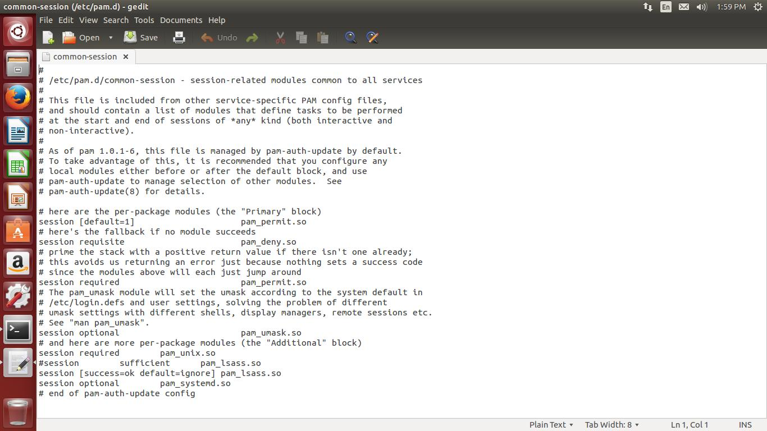

* Find the line that states the following:   
  session sufficient pam_lsass.so
* Replace it with:   
  session [success=ok default=ignore] pam_lsass.so

**Step 10:** **Give sudo access to users/groups**

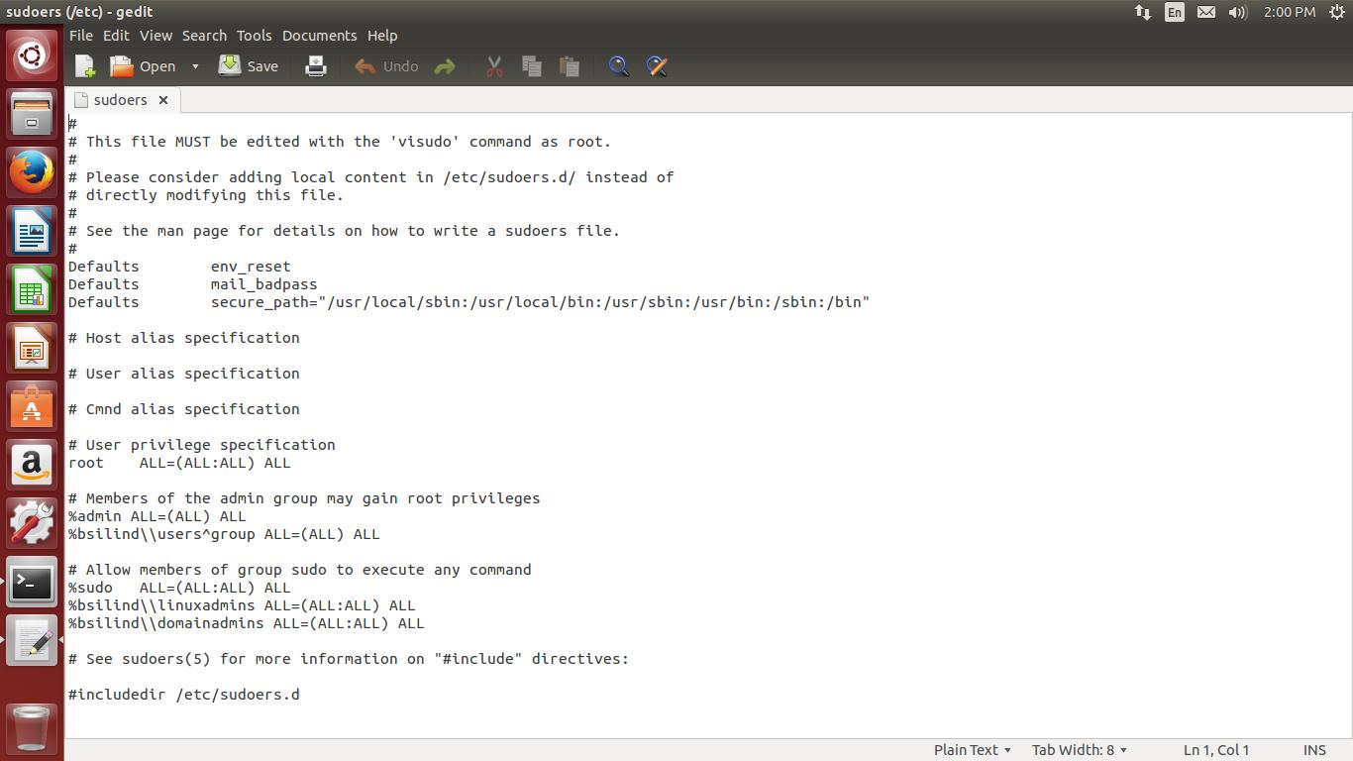

* for group use %:

%DOMAINNAME\\domain^Users ALL=(ALL:ALL) ALL

**Note:** Use ^ if there is any gap

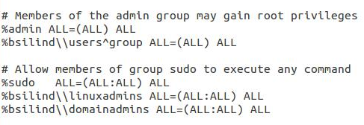

**Note:** Please comment before %bsilind\\Linuxadmins as it is not required

**Step 11:** Join Domain at Start Up ( Important Step)

* For this you will have to create a script and allow it to be run during startup.

Create the file:

**sudo nano /etc/init.d/domainjoin**

Enter the script in the file, adjust as required:

**#!/bin/bash**

**#Join Ubuntu Linux to Domain**

**i=0**

**while [ $i -lt 20 ]; do**

**sleep 1**

**is_up=$(ping -q -w 1 -c 1 `ip r | grep default | cut -d ' ' -f 3` > /dev/null && echo 1 || echo 0)**

**let i=$i+1**

**if [ $is_up -eq 1 ]; then**

**sudo domainjoin-cli join DOMAIN USER PASSWORD**

**let i=999**

**fi**

**done**

Save the file.  Now make it executable

**sudo chmod +x /etc/init.d/domainjoin**

Now that you have an executable in the /etc/init.d directory you can add it to the boot sequence using this command:

**sudo update-rc.d domainjoin defaults**

**Step 12**: Install and Configure LightDM GTK+ Greater 1.7.1

Install the latest version 1.7.1 LightDM GTK+ Greeter

* From the Terminal type the below command to install LightDM GTK+ Greeter

sudo add-apt-repository ppa:lightdm-gtk-greeter-team/stable

sudo apt-get update

sudo apt-get install lightdm-gtk-greeter

* Edit the below from terminal

sudo gedit /etc/lightdm/lightdm-gtk-greeter.conf

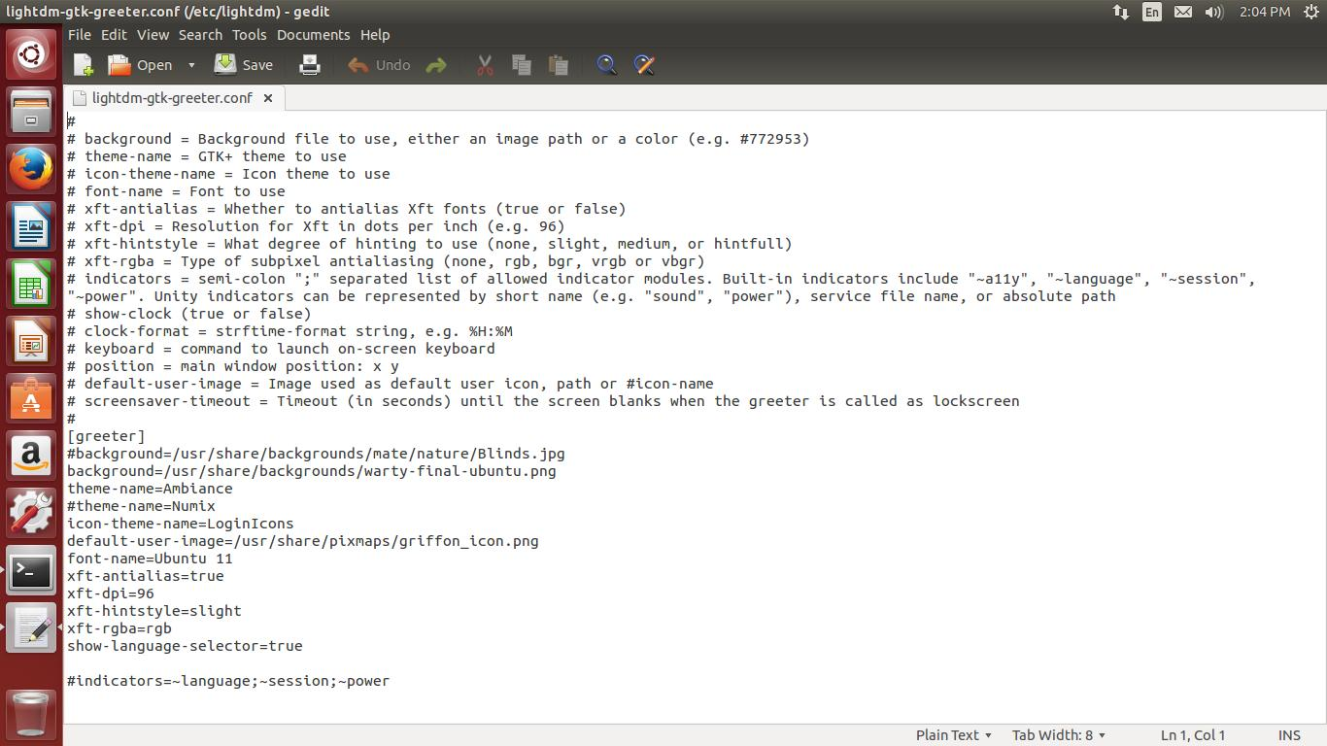

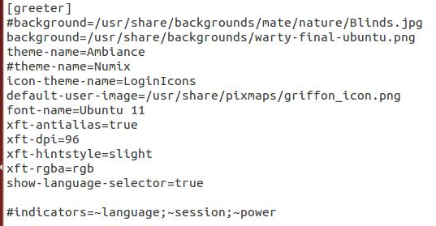

**Step 13:** Edit the below command from terminal as below

sudo gedit /usr/share/lightdm/lightdm.conf.d/50-unity-greeter.conf

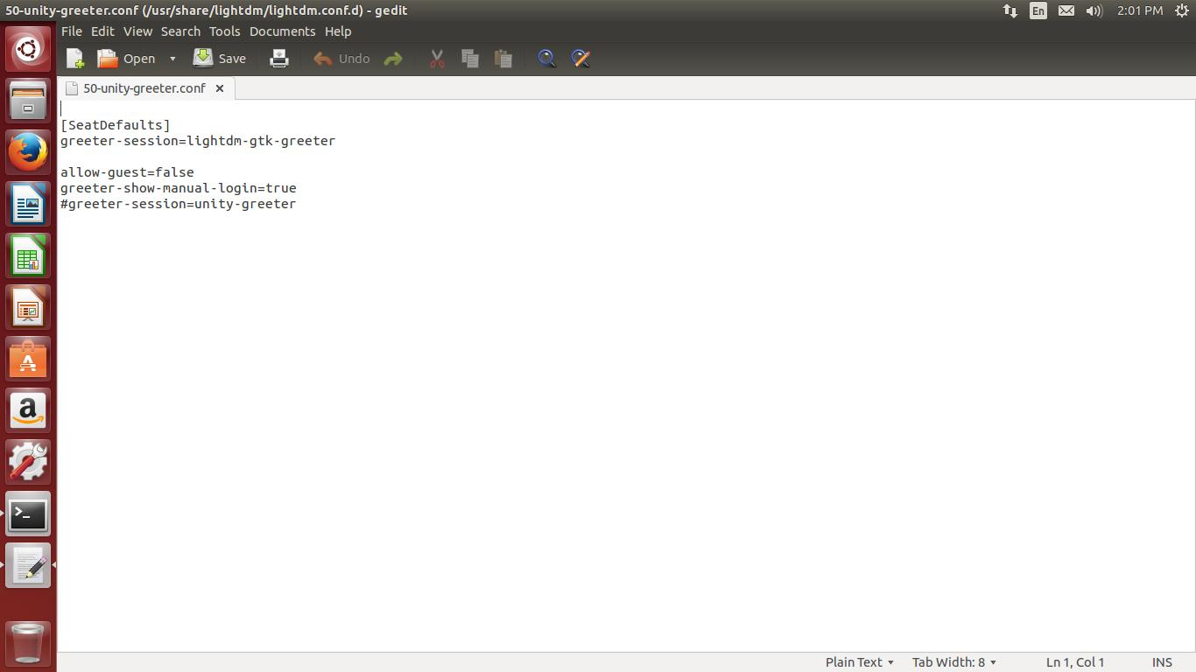

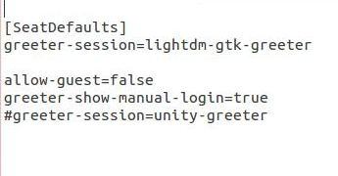

**Step 14:** Restart your machine and login a domain user

**Step 15:** Login as admin user and install wine and samba from Software Update Center

**Step 16:** Login as user and install Google Chrome for Ubuntu 64 bit, IPMSG 64 Bit and

Evolution software for mail.

**Step 17:** If the user want Sudo privilege follow as below

**Sudo gedit /etc/sudoers**

# User privilege specification

root ALL=(ALL:ALL) ALL

newuser ALL=(ALL:ALL) ALL

**Step 18: How to Take Evolution Mail backup**

The Evolution data structure has changed quite a lot -- the directory .evolution

is no longer used. If you made a backup from within Evolution before

upgrading, you should be able to restore it (hopefully). Otherwise it will be a bit

troublesome

Basically, Evolution currently stores its configuration in 3 different folders:

* .local/share/evolution
* .local/config/evolution
* .gconf/apps/evolution